**Assignment 4**

**Question 1 (1 point)**

1. What is the main difference between a project management and operational management?
2. Find and describe at least 4 characteristics of the following project:

The CEO of Go-Yoyo Toys wants to create a new yoyo that has a cord that will never tangle. Fred, Alex and John will work fulltime to develop the yoyo and Frank, from the Finance Department will gather all the info required to ensure we move forward. A budget of $46,000 is assigned to the project and it must be completed before the Christmas Show at the NAC.

**Question 2 (2 point)**

Using the P.E.R.T diagram shown below, answer the following

1. The project manager has taken actions to reduce the length of the activities D and F by one day each. What will be the impact on the project and why?
2. Following this change, what can the project manager do if she wishes to finish the project one day early?

*Légende / legend:*

*Lettre = nom de l’activité; Letter = Name of the activity*

*chiffre = durée de l’activité; number = length of the activity*

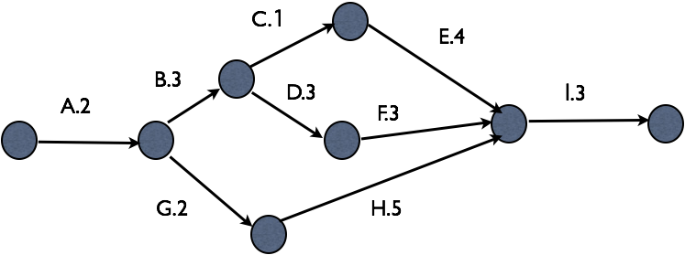

**Question 3 (1 points)**

You have a great idea for a new Artificial Intelligence-Based Application that will reduce expenses of hair salons. You know a competitor is working on the same product but you want to be first to market.

Identify if the entries in the risk register below are positive or negative and what type of risk response is proposed (avoid, transfer, mitigate, accept, exploit, share or enhance):

Register:

1 – The only experienced programmer is 3 months pregnant, if she leaves early or the project is extended then we will face difficulties to complete the project.

Risk response : Hire a headhunting firm to find an appropriate replacement.

2 - Material is very expensive and is at risk to be stolen.

Risk response: Purchase an insurance policy

1. – If the testing phase with humans is too long, we will lose the people who are going back to school

Risk Response: Hire more staff to reduce the testing phase length

4 – The Canada 150 celebration is prevalent in the media this year and you are looking for ways to piggy-back on some of their advertising to get more exposure.

Risk Response: You hire a communication specialist to find a way to visibly place your product in Canada 150 celebration advertising.